**Logo**

Goto site settings

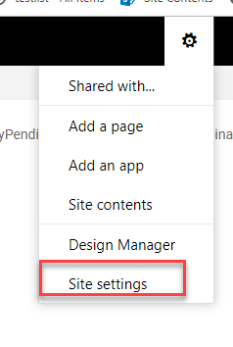

Click on “title description and logo” link

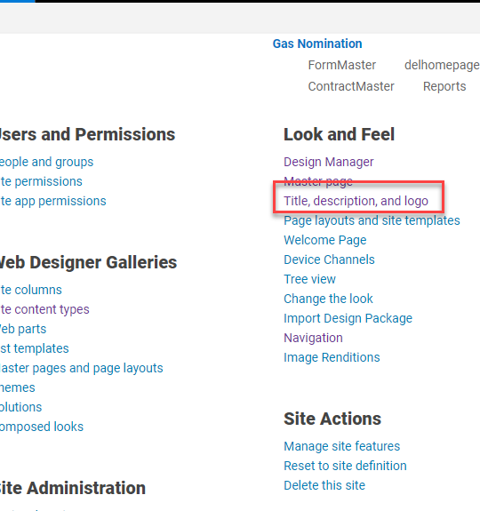

Write title of you logo and select logo. (I have selected from sharpoint style library)

